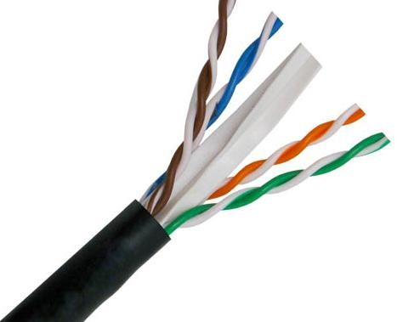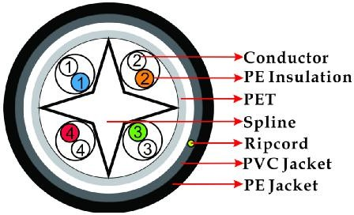

**SPECIFICATION**

**DESCRIPTION**

CAT6 4Pair 23AWG Solid CCA **Technical Data**

Outdoor Jacket UV Rated Waterproof Rated Temperature 70 °C

Rated Voltage 30V

801

|  |  |  |
| --- | --- | --- |
| **FEATURES** | Reference Standard | EIA/TIA 568 & ISO/IEC 11 |
| * High-Performance Data Cable | **Conductor** | **Solid CCA** |
| * CAT6 Unshielded Twisted Pairs | Material | Copper Clad Aluminum |
| * Easily Identified Color-Striped Pairs | AWG | 23AWG |
| * 23AWG Solid CCA | Conductor Diameter | 4 × 2 × 1/0.56 ± 0.01mm |
| * Outdoor UV Rated Jakcet Waterproof |  |  |
|  | **Insulation** | **HDPE** |

**APPLICATION**

High Speed Horizontal Cabling

100 Mbps TPDDI , 1000 Base T , 622 Mbps ATM

AVG. Thickness 0.21mm

Insulation Diameter 1.01 ± 0.01mm

# High twisted & Ripcord Yes

IEEE802.3/IEEE802.5 , 10 Base-T , 100 Base-T4 **Separator PP**

1000 Base-X , 100 Base-VG , Gigabit Ethernet

|  |  |  |
| --- | --- | --- |
| **Jacket** |  | **LDPE (UV)** |
| AVG. Thickness |  | 0.61 ± 0.01mm |
| Outer Diameter |  | 6.2 ± 0.1mm |
| Color |  | Black |
| Marking |  | Available |
| **Color of Pairs**  Pair 1 | Blue | White-Blue |
| Pair 2 | Orange | White-Orange |
| Pair 3 | Green | White-Green |
| Pair 4 | Brown | White-Brown |

|  |  |  |
| --- | --- | --- |
| **MODEL** |  | |
| **No** | **Length** | **Color** |
| 140201 | 1000ft(305m) | Black |

 

**PACKING**

**PERFORMANCE**

Wooden drum **Mechanical Properties**

Outer Brown Carton PVC Tensile Strength(Mpa) ≥ 13.8

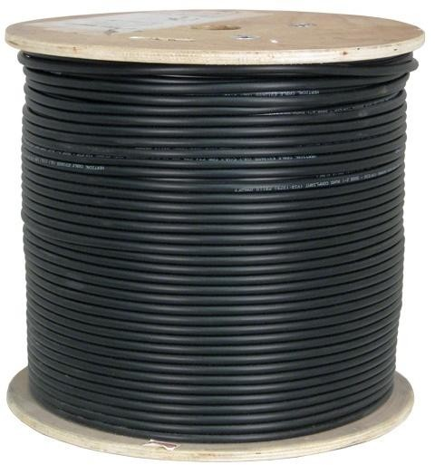Bending Radius ≥ 4xOD(without load) Temperature range during operation: -40°C ~ 75°C

# Electrical Properties

Max. Con. DC resistance 75 ohms/km at 21 ºC

1.0 - 100 MHz Impendance 100 ± 15 (Ohms)

100 - 250 MHz Impendance 100 ± 15 (Ohms)

250 - 550 MHz Impendance 100 ± 35 (Ohms)

1.0 - 250 MHz Delay Skew ≤ 45 Pair-to-ground Cap. Unbalance ≤ 330Resistance Unbalance ≤ 5%