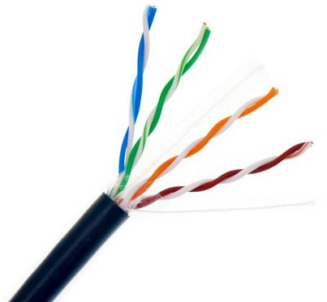 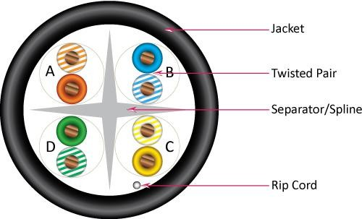

**DESCRIPTION**

CAT6 4Pair UTP 23AWG Solid Bare Copper **Technical Data**

Outdoor Jacket UV Rated Waterproof Rated Temperature 70 °C

**SPECIFICATION**

Rated Voltage 30V

Reference Standard EIA/TIA 568 & ISO/IEC 11801

**FEATURES**

* High-Performance Data Cable **Conductor Solid Bare Copper**
* CAT6 Shielded Twisted Pairs Material Bare Copper (100% Copper)
* Mylar and drain wire AWG 23AWG
* 23AWG Solid Solid Bare Copper Conductor Diameter 4 × 2 × 1/0.57 ± 0.01mm
* Outdoor UV Rated Jakcet Waterproof

**APPLICATION**

High Speed Horizontal Cabling

100 Mbps TPDDI , 1000 Base T , 622 Mbps ATM

# Insulation HDPE

AVG. Thickness 0.21mm

Insulation Diameter 1.01 ± 0.01mm

# High twisted & Ripcord Yes

IEEE802.3/IEEE802.5 , 10 Base-T , 100 Base-T4 **Separator PP**

1000 Base-X , 100 Base-VG , Gigabit Ethernet **Jacket LDPE (UV)**

AVG. Thickness 0.68 ± 0.1mm

**MODEL**

**No Length Color**

140401 305M Black

Outer Diameter 7.8 ± 0.1mm

Color Black

140402 500M Black Marking Available

|  |  |  |  |
| --- | --- | --- | --- |
| **Shielded** | **Color of Pairs**  Pair 1 Blue | | White-Blue |
| Drain Wire | Pair 2 | Orange | White-Orange |
| PE Tape ( Mylar ) | Pair 3  Pair 4 | Green  Brown | White-Green  White-Brown |

**HSD CABL [WWW.HS](http://WWW.HSDCABLE.COMhsdcable.en.alibaba.com/)DCABLE.COM**

**Email : [sales@hsd](mailto:sales@szcambo.com)cable.com Tel : +86 135288**[hsdcable.en.alibaba.com](http://szcambo.en.alibaba.com/)

**CAT6 OUTDOOR UNSHIELDED UV RATED**

**@ Copyright 2013-2020 Hsdcable Ltd . All rights reserved**

 

**PACKING**

**PERFORMANCE**

Wooden drum **Mechanical Properties**

Outer Brown Carton PVC Tensile Strength(Mpa) ≥ 13.8

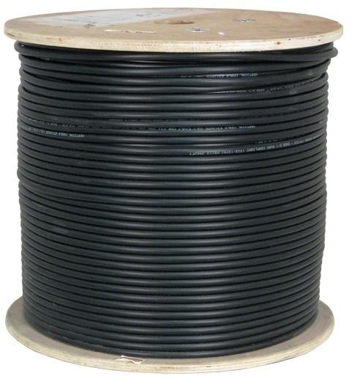Bending Radius ≥ 4xOD(without load) Temperature range during operation: -40°C ~ 75°C

# Electrical Properties

Max. Con. DC resistance 75 ohms/km at 21 ºC

1.0 - 100 MHz Impendance 100 ± 15 (Ohms)

100 - 250 MHz Impendance 100 ± 15 (Ohms)

250 - 550 MHz Impendance 100 ± 35 (Ohms)

1.0 - 250 MHz Delay Skew ≤ 45 Pair-to-ground Cap. Unbalance ≤ 330 Resistance Unbalance ≤ 5%

**HSD CABLE [WWW.HS](http://WWW.HSDCABLE.COMhsdcable.en.alibaba.com/)DCABLE.COM**